|  |  |
| --- | --- |
| **Date** | **18 November 2022** |
| **Team ID** | **PNT2022TMID26844** |
| **Project Name** | **PROJECT - SMART CROP PROTECTION SYSTEM FOR AGRICULTURE** |

**SPRINT 4**

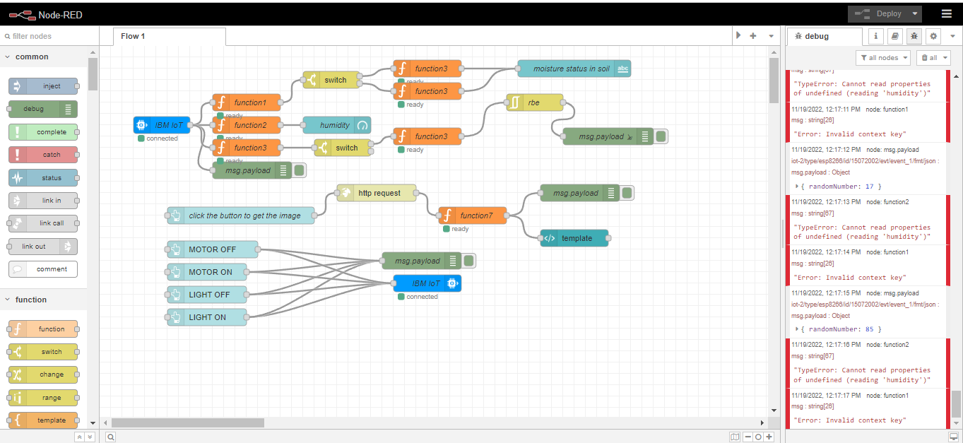

In node red I cant able to get output. But in ui page I can able to get motor and light commands.